Since today 28/07/2021, after almost 20 years, there is still no clear guide on how to create a server for this game, I create for the umpteenth time a post, with all the information collected so far.

to tell the truth I have dedicated myself for a few days to the creation of a server for this game, I am able to develop software with many different technologies, (both front-end and back-end side) but not with the technologies that make up this project , also because they are very old and there is no material on the internet to correct the errors.

LS google Drive Source Files : https://drive.google.com/u/1/uc?id=1kUgJKnl6CeoCsSUpEkD7qIMF7aix7dbR&export=download

1. **Download vs2010 ultimate:** <https://my.visualstudio.com/Downloads?q=visual%20studio%202010%20Ultimate&wt.mc_id=o~msft~vscom~older-downloads>

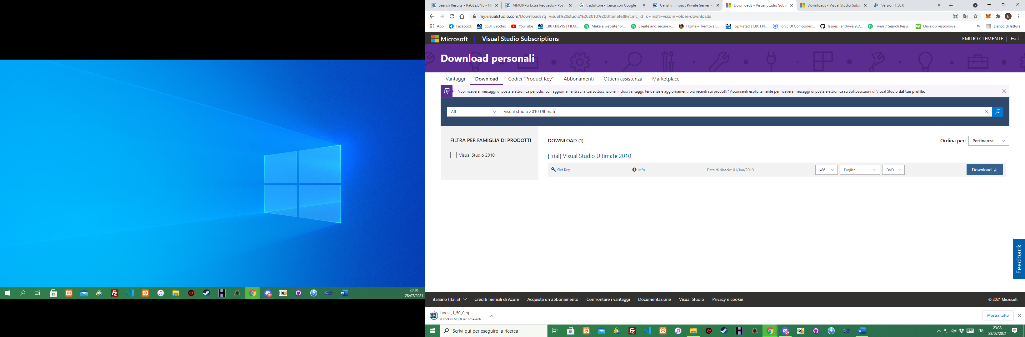

Install it with program for iso, like “ daemon tool “.

1. **Download boost1_5_0 and install it :**

<https://www.boost.org/users/history/version_1_50_0.html>

1. **Download Microsoft DirectX SDK June 2010 and install it :**

https://www.microsoft.com/en-us/download/details.aspx?id=6812

1. **Unzip “LS” folder and open it on vs2010 in this way:**

File->open project, find existing projects in the directory.

1. **How to setup boost library and sdk(june2010):**

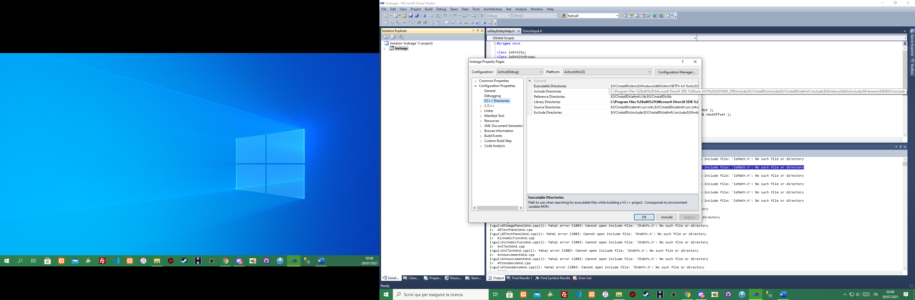

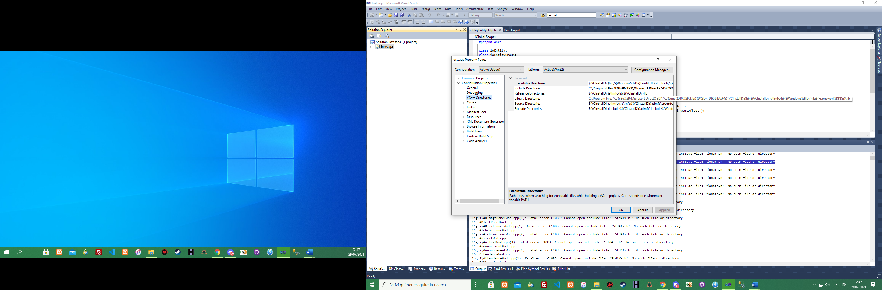

1. Delete Xtrap folders and files in all project:

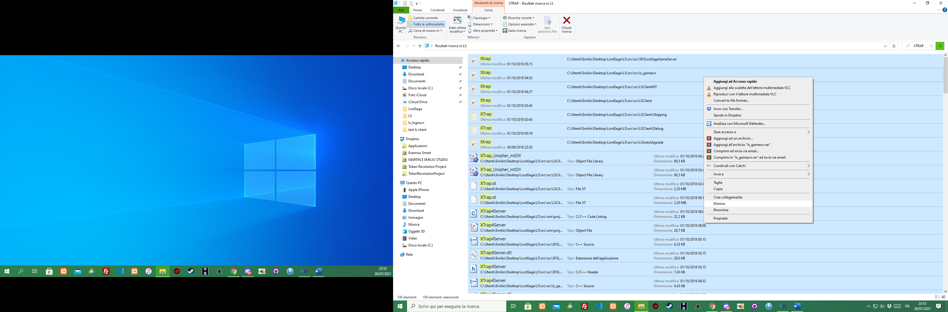

1. Create Database on Microsoft® SQL Server® 2008 R2 SP2 - Express Edition

Download and install : <https://www.microsoft.com/it-it/download/details.aspx?id=30438>

Only SQLEXPRADV_x64_ENU.exe or SQLEXPRADV_x86_ENU.exe

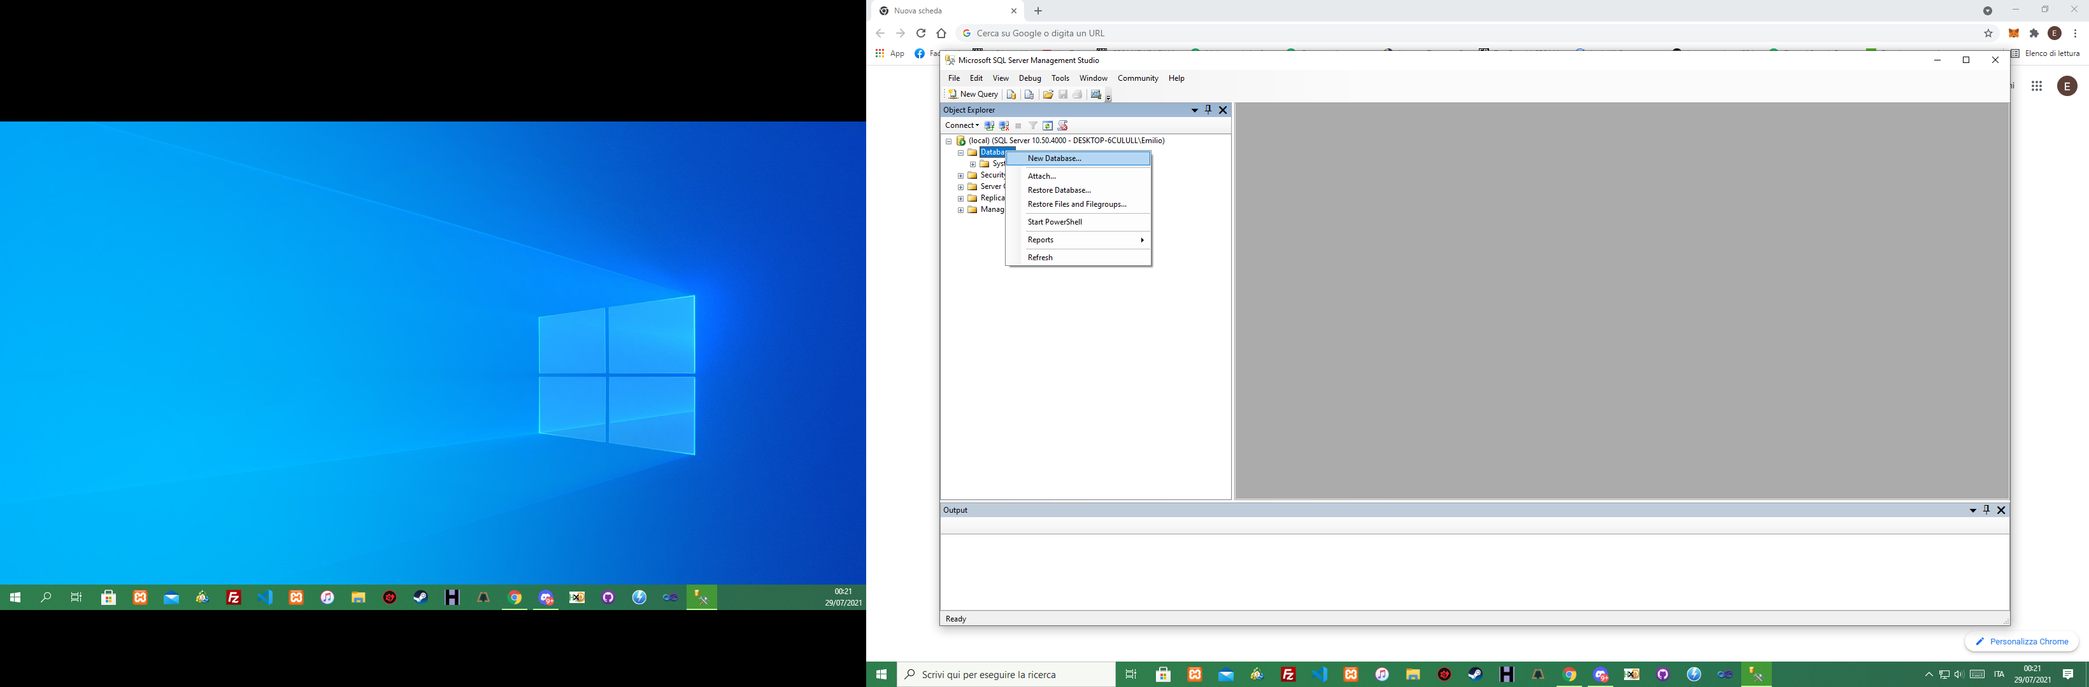

Create 4 db:

LosaGame, LosaGame_B, LosaGame_Log and LosaLogData

pay attention to the size:

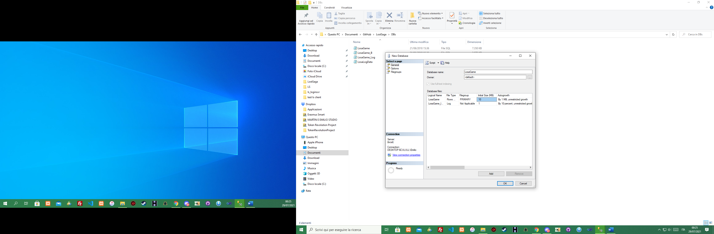

Open LosaLogData and delete most of these lines:

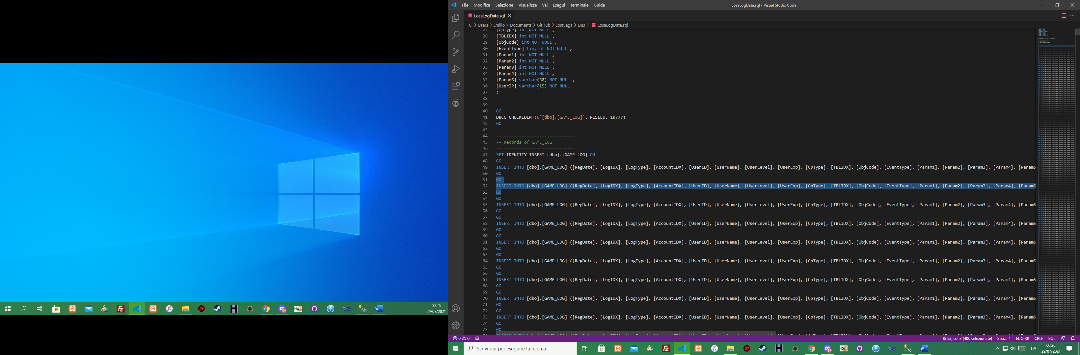

they are nothing more than database rows, they do not delete its structure, thus the file becomes small and can be easily imported into the database.

Import all DBs Files:

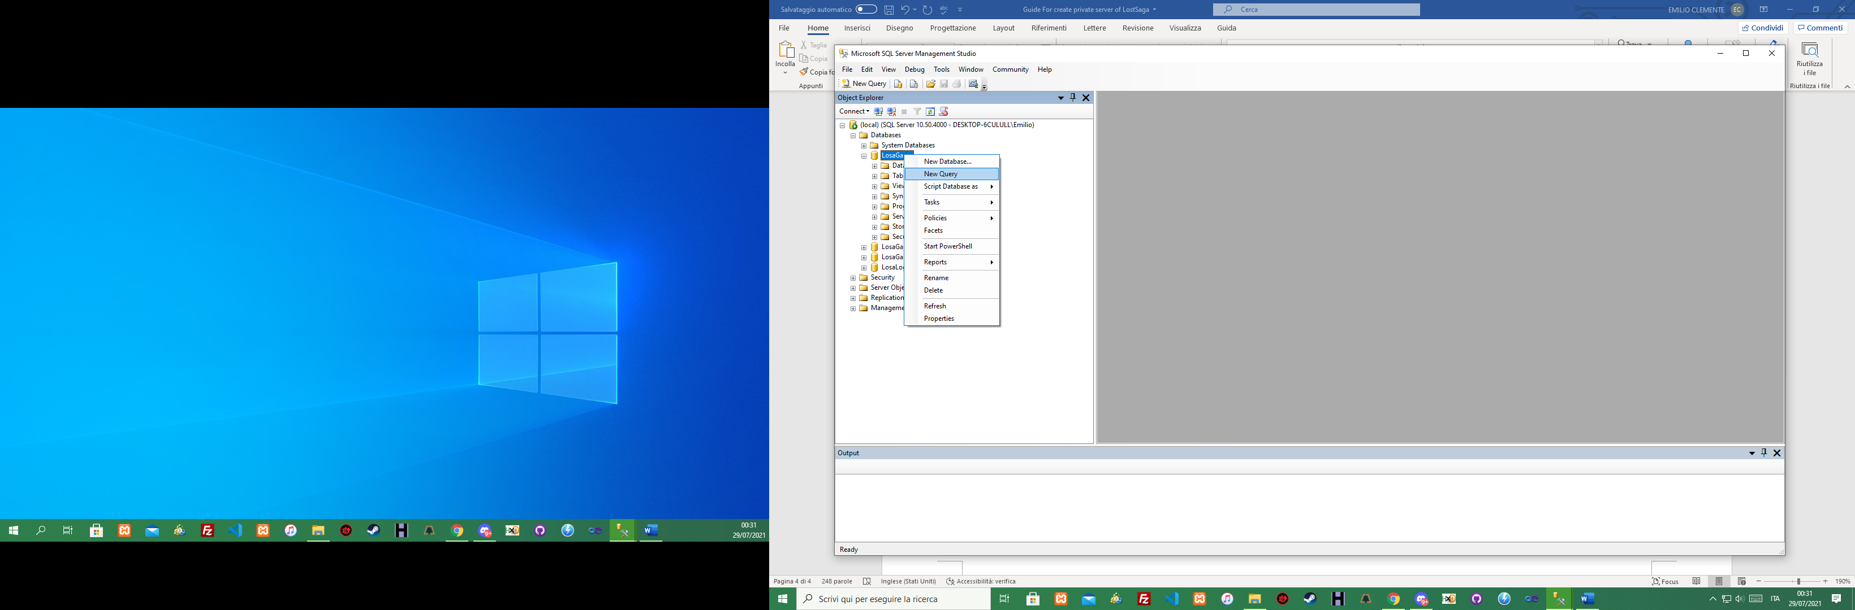

This is procedure for LosaGame, but is the same for all.

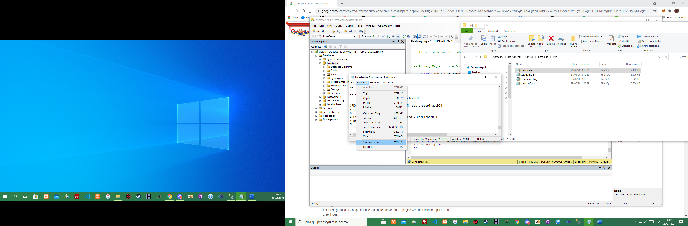

Copy and paste in the query window:

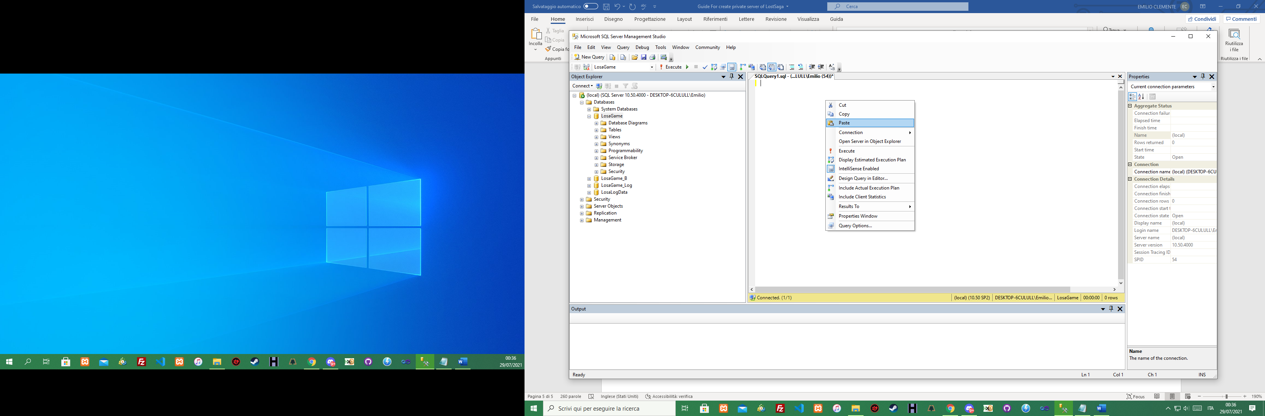

Now execute.

Connect Db for every db created to vs2010 :

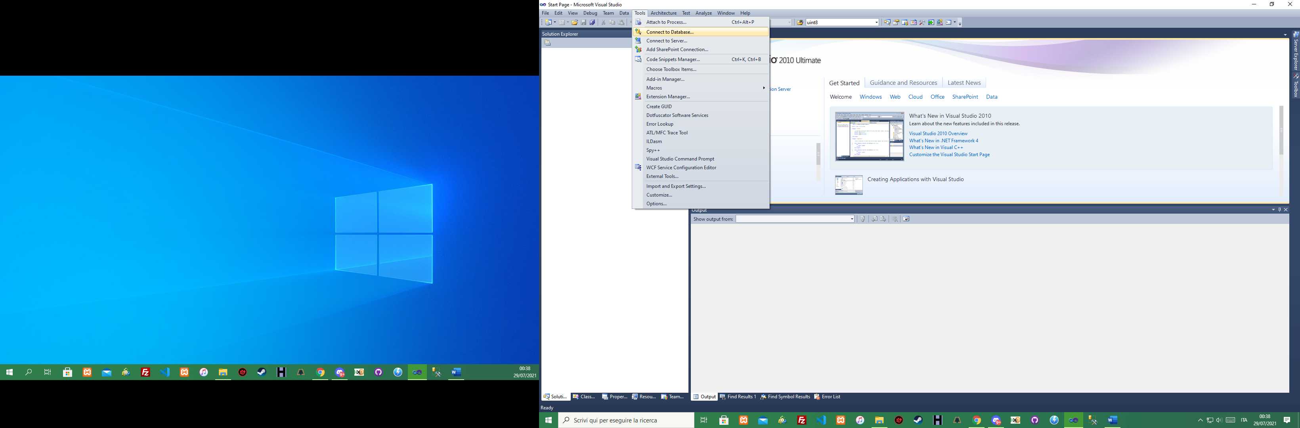

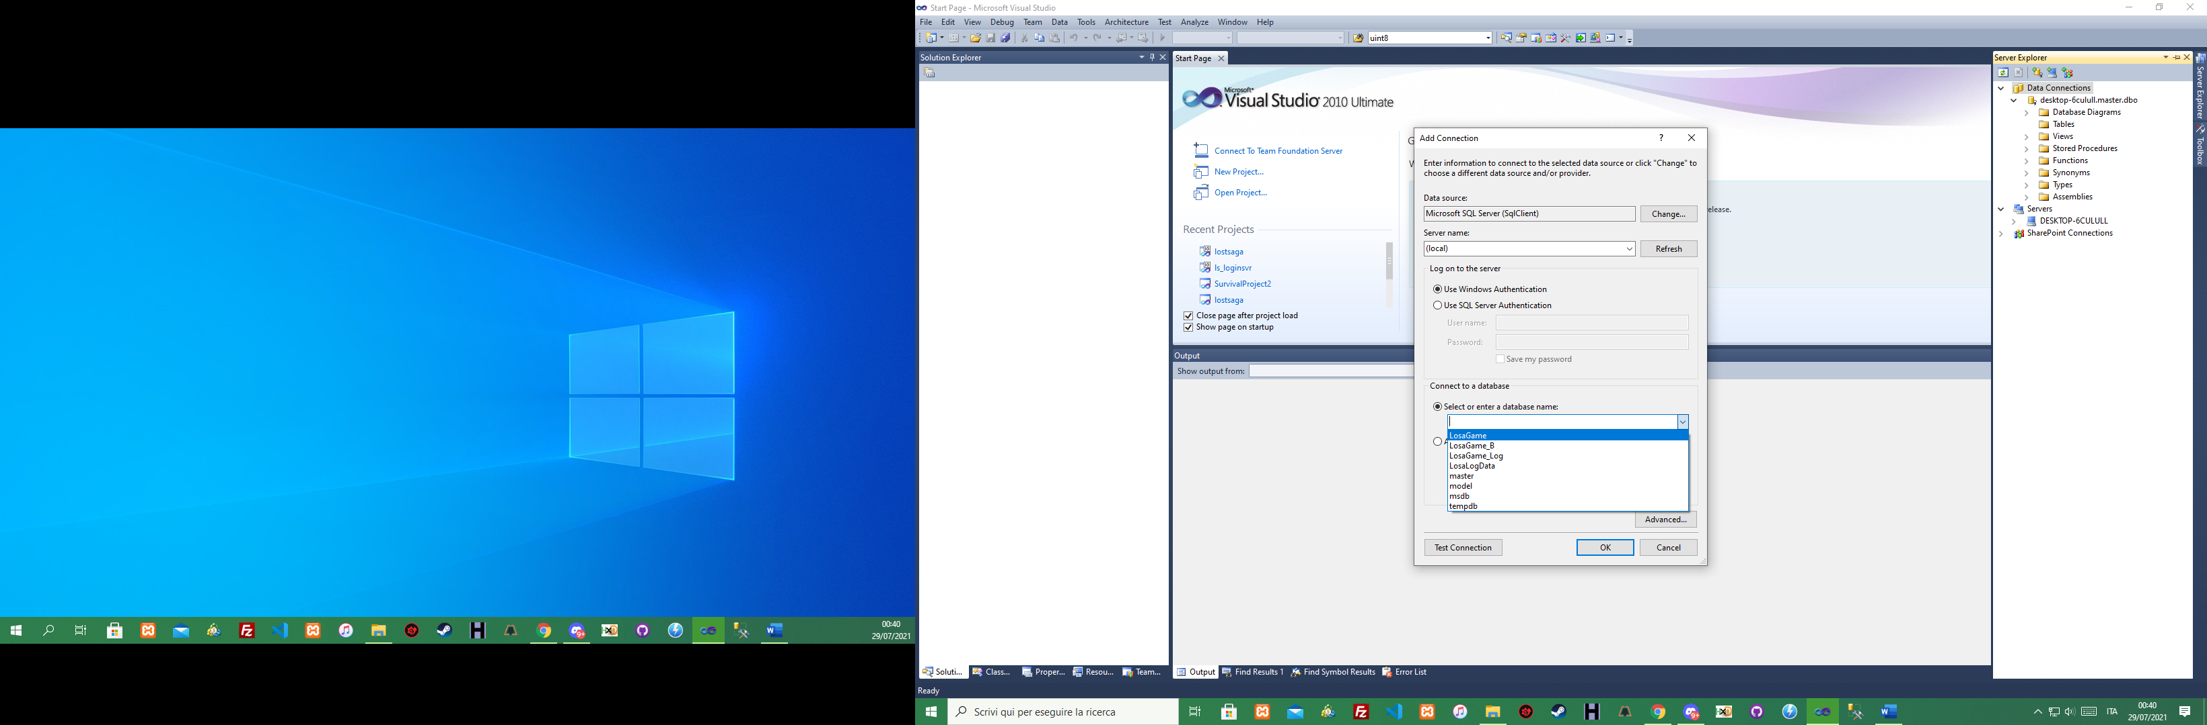

always in the project properties you can choose between, start an .exe or create a file:

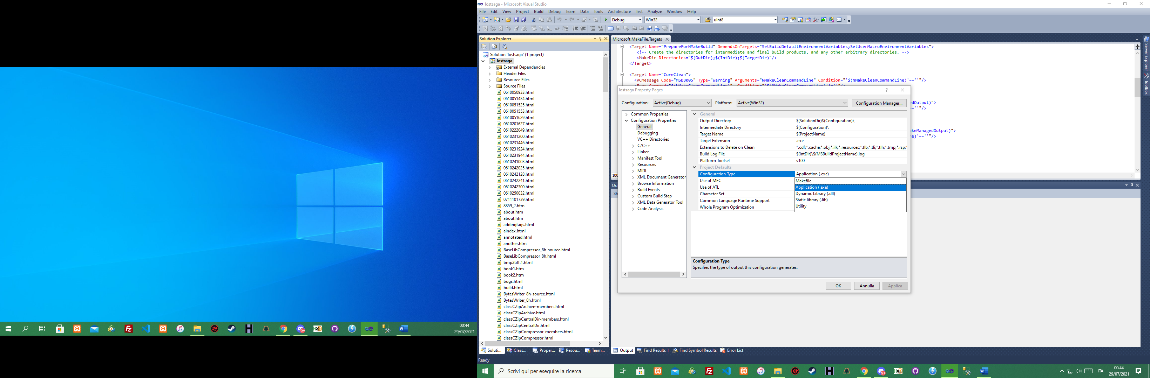

Final conclusions: Now you can compile the project (Build->Build Solution), without debugging, if you use debug with a new project, you will have more than 3k of errors and fixing them others will come out, like a dog chasing its tail, if we try to start the lostsaga.exe file in the src / src / LSCLIENT / debug /lostsaga.exe, we will always get the "app cmd error".

[UPDATE] 30/07/2021

**HOW TO COMPILE LSCLIENT (SurvivalProject2).**

**(coming soon)**